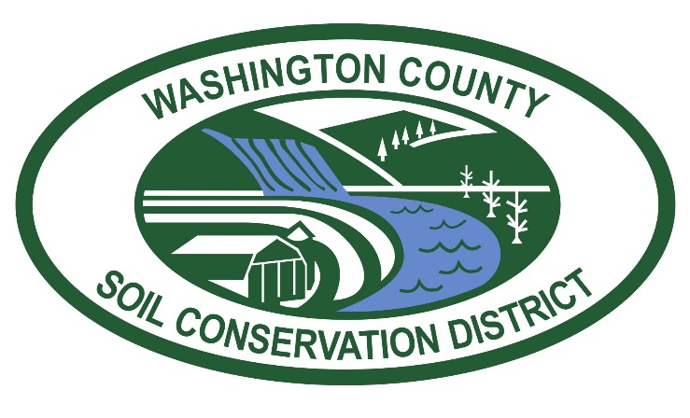

WASHINGTON COUNTY SOIL CONSERVATION DISTRICT
Fee Transmittal Form
(Form Updated September 1, 2022)

Project Name: __________________________________________________

Disturbed Area Quantity: ________________________________________

Project Type (Circle One):

- Flat Fees:

Environmental Site Design Concept Plans - $500
2-Year Updates - $565
Pond As-Builts - $630
Field Services - $785

Engineered Soil Erosion and Sediment Control Plans
(Minimum Fee - $1,380 for plans 3.0 acres or less; $630 Application Fee included)

Site Plans… – Application Fee ($630) is included in the fees shown on the table;
otherwise, a tiered calculation is required based upon the disturbed area quantity.

5-Year Updates (Mining/Quarries) – Fee based on adopted fee schedule and disturbed area quantity, not to exceed fee for 60 acres.

Fees will not be accepted unless accompanied by this completed “Fee Transmittal Form”!

